**SQL ASSIGNMENT 1**

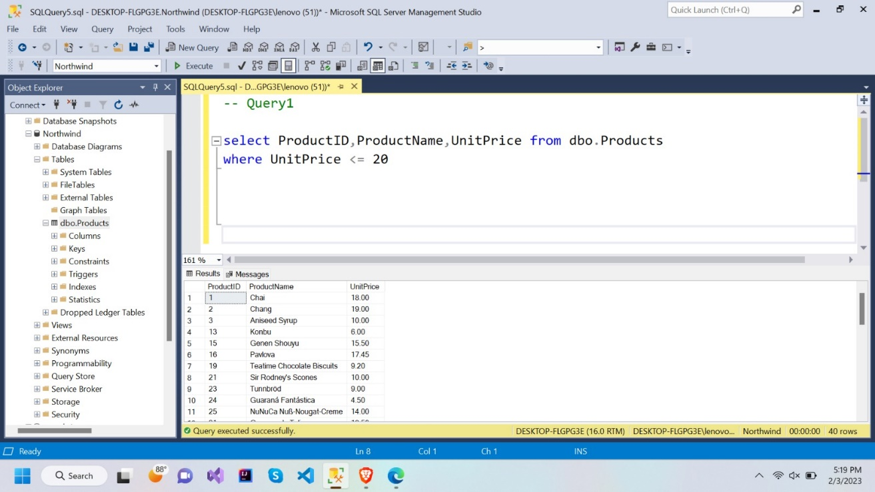1**.**Write a query to get a Product list (id, name, unit price) where current products cost less than $20.

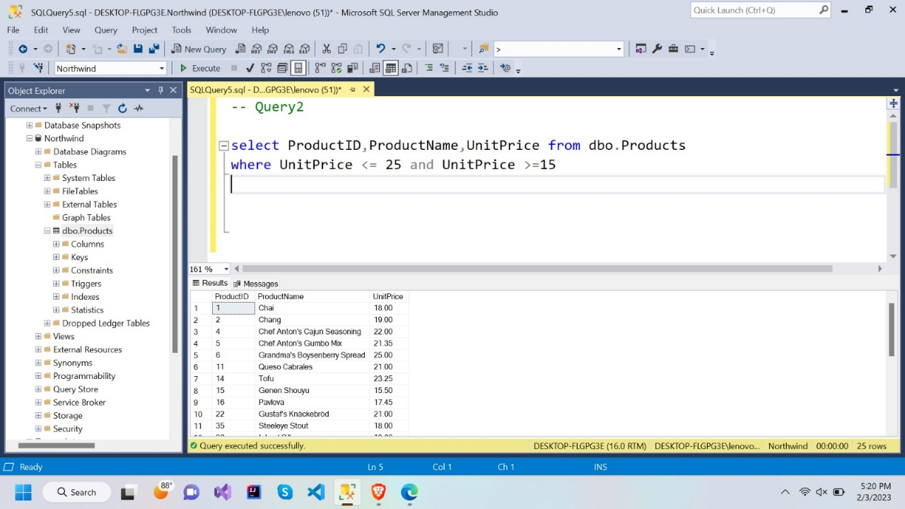2.Write a query to get Product list (id, name, unit price) where products cost between $15 and $25

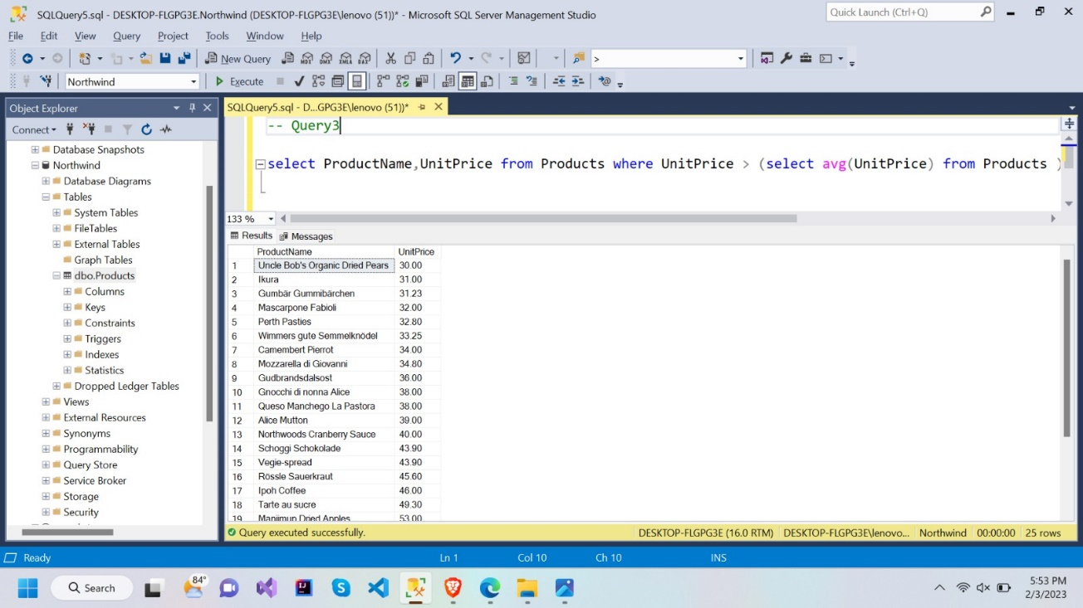3. Write a query to get Product list (name, unit price) of above average price.

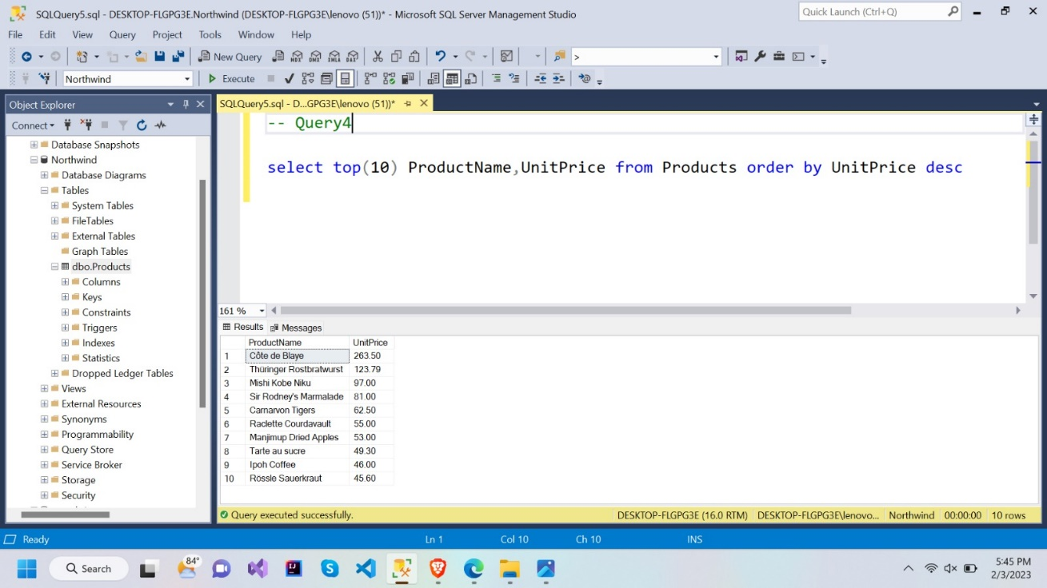4. Write a query to get Product list (name, unit price) of ten most expensive product

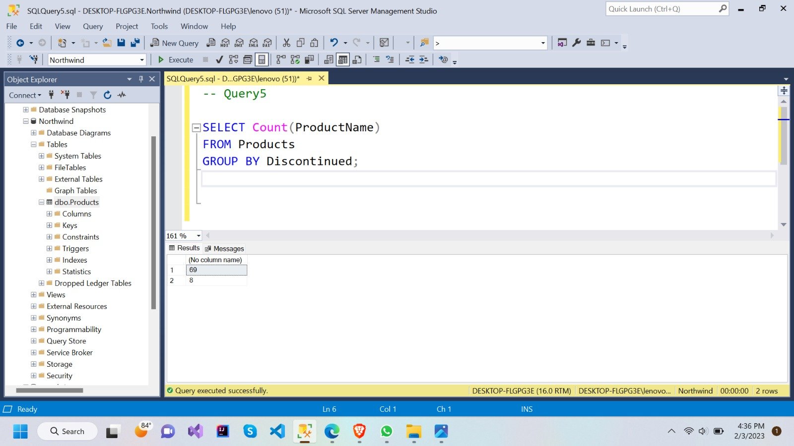5. Write a query to count current and discontinued products

6. Write a query to get Product list (name, units on order , units in stock) of stock is less than the quantity on order

